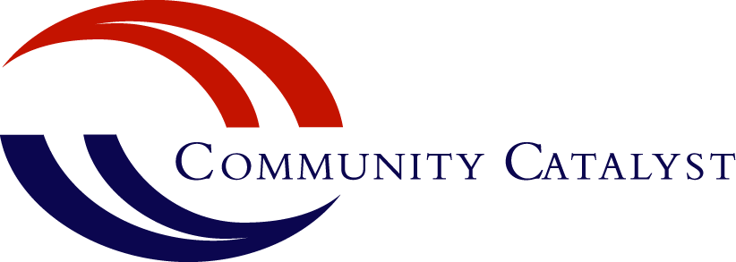

Medicaid Offers New Strategies to Prevent Substance Misuse
Medicaid and the Children's Health Insurance Program (CHIP) bring free or low-cost health care to half of all low-income children across the United States. The federal Centers for Medicare and Medicaid Services (CMS) are working to ensure these children also receive preventive services. The CMS guidance highlighted below generates new possibilities for states to prevent drug and alcohol misuse among young people. Consumer advocates can play an important role in translating this guidance into action.
Advocates can educate state officials, providers and consumers about these opportunities. They can work with school districts and Medicaid officials to identify specific prevention models, such as SBIRT (screening, brief intervention and referral to treatment), that can be supported by Medicaid. SBIRT is a set of tools to help identify alcohol or drug problems in young people and guide intervention if a problem exists. With the help of advocates, the following CMS guidance can be leveraged to support SBIRT and other public health approaches to preventing substance misuse among young people.
Schools can receive Medicaid reimbursement for services offered without charge
Summary: As of December 15, 2014, CMS allows public agencies or programs, including public schools, to receive Medicaid reimbursement for “free care” offered to Medicaid enrollees.

Relevance to youth SBIRT: This change removes a significant financial barrier for public schools that wish to provide universal drug and alcohol screening and brief intervention to students. Previously, schools could not bill Medicaid for care provided to Medicaid-eligible students if it was available for free to other students. Now schools can offset the cost of a drug and alcohol prevention initiative (such as SBIRT) with Medicaid reimbursement.

Action needed at state level: This change automatically went into effect in all states in December 2014. Advocates may need to inform state Medicaid officials of this change, and work with school districts to identify ways they can use this opportunity to develop and implement substance use prevention efforts.

Additional information: CMS Bulletin: Medicaid Payment for Services Provided without Charge
Non-licensed providers can deliver preventive services
Summary: As of January 1, 2014, practitioners other than physicians or licensed practitioners can now provide preventive services – and bill Medicaid for these services – if the services are recommended by a physician or other licensed practitioner. Prior to this change, only licensed providers were eligible to deliver preventive services under Medicaid.

Relevance to youth SBIRT: This creates an opening for a broad range of health care workers to provide drug and alcohol screening and/or assessments to young people. Most importantly, this enables expansion of the role of community-based providers, such as community health workers, in the detection of and early intervention for substance misuse. This has the potential of bringing screening to many more young people, including those who may not be connected to a pediatrician or primary care doctor.

Action needed at state level: States will have to submit a State Plan Amendment (SPA) to receive Medicaid reimbursement for non-licensed practioners. The SPA needs to include what services will be covered, who will provide those services and practitioner qualifications. Advocates can encourage states to expand use of community health workers to address substance use.

Additional information: CMS Bulletin: Update on Preventive Services Initiative

Preventive Services Regulation Questionnaire: Questions to Consider (p. 5)
Alcohol and drug screening is required under the EPSDT benefit
Summary: The Early and Periodic Screening, Diagnostic and Treatment (EPSDT) benefit mandates well-child visits (periodic health screenings) for all Medicaid-eligible children under age 21. For any condition identified, the EPSDT benefit covers medically necessary treatment costs. On January 26, 2015, CMS clarified that EPSDT includes age-appropriate mental health and substance use screening as part of well-child exams.

Relevance to youth SBIRT: EPSDT includes many screening and assessment requirements. States, health plans and providers often struggle to comply with EPSDT. This CMS guidance underscores the importance of drug and alcohol screening and may encourage state EPSDT officials and providers to prioritize these screenings during well-child visits.

Action needed at state level: States are required to establish a schedule for screenings and developmental assessments under EPSDT. Advocates can ensure drug and alcohol screening is explicitly listed on their state’s schedule.

Advocates can prompt conversations with providers about this requirement and the importance of early detection of youth substance misuse. Advocates can raise awareness among young people about the drug and alcohol screenings they should expect, and work with parents and caregivers to make sure these screenings are provided.

Additional information: CMS Bulletin: Coverage of Behavioral Health Services for Youth with Substance Use Disorders

CMS Bulletin: Prevention and Early Identification of Mental Health and Substance Use Conditions
State-by-State Guide to Behavioral Health Services for Children Covered by Medicaid and CHIP

Authored by,
Melissa Ough, Policy Analyst

