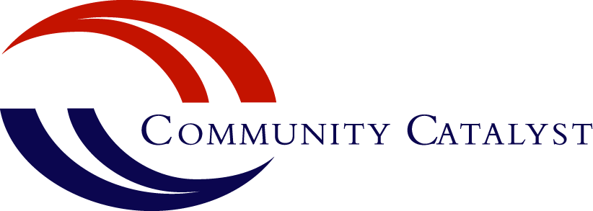

Closing the Coverage Gap Helps Combat Drug and Alcohol Problems

Accepting federal funds to close the health insurance coverage gap in all states would expand access to treatment for drug and alcohol problems. There are more than1.25 million uninsured Americans with drug and alcohol problems. Many of them are unable to afford the cost of the treatment they need to get well. Drug and alcohol treatment is cost effective – saving as much as $22 in the health care and criminal justice systems for every $1 spent on treatment. States around the country are already seeing the social and economic benefits associated with increased access to treatment for drug and alcohol problems and other medical care.

Providing health insurance coverage for those who fall into the gap – working families, veterans and others who are not eligible for private insurance tax credits but who can’t afford to buy coverage on their own – ensures that treatment for drug and alcohol problems is available to those who need it. In short, increasing coverage through Medicaid expands treatment options for people with alcohol and drug problems.

Drug and Alcohol Problems Overview

Substance use disorders are a category of treatable chronic brain diseases caused by misuse of alcohol or drugs. Substance use disorders challenge people from all walks of life, without regard to age, occupation or income level. Substance use disorders can range from binge drinking, to drug or alcohol dependence, to addiction.

Untreated substance use disorders have a detrimental effect on state budgets. States spend an average of 15 percent of their budgets on the consequences of untreated drug and alcohol problems. These costs permeate health care, criminal justice, disability payments, and other social services and also include lost taxes from lower employment rates.

Closing the Gap: Nationwide Successes

Closing the coverage gap is yielding great results across the country. The federal funds are already set aside, and it’s up to states to accept these funds to close the gap and offer coverage to thousands of Americans.

- In states that have already closed the coverage gap, a U.S. Department of Health and Human Services report finds a significant drop in uninsured people using hospital emergency rooms and in hospital admissions. Projected savings in uncompensated care are $4.2 billion in these states.
- A recent report from the Kaiser Family Foundation says states that closed the coverage gap are projecting lower state spending growth in Medicaid compared with states that have rejected the federal funding.
- Treatment for substance use disorders results in savings in health care costs, reducing the use of expensive emergency services, and in the criminal justice system, reducing crime, recidivism and incarceration rates.
Treatment Gaps and Recovery

While people from all walks of life struggle with substance use disorders, access to treatment options is limited by income. Only 7 percent to 12 percent of uninsured people with drug or alcohol problems get treated, leaving millions of individuals with substance use problems without access to treatment.

Prevention, drug enforcement, treatment and recovery services are all part of managing the effect of substance use disorders on individuals, families and communities.

- Prevention: In fiscal year (FY) 2014 the federal government allocated more than $500 million to states for drug and alcohol prevention initiatives.
- Enforcement: In FY 2014 federal programs provided an estimated $256 million to states for drug-related law enforcement.
- Treatment: States have the opportunity to accept federal funds and increase access to affordable and effective substance use disorder treatment. Closing the coverage gap and allowing uninsured Americans access to treatment for drug and alcohol problems is the missing piece in the nation’s ability to address alcohol and drug problems nationwide.
- Recovery: Millions of people complete treatment for drug and alcohol problems and enter into long-term recovery. Coverage for recovery services such as outpatient counseling can ensure that people get the continued support they need to stay well, hold jobs, pay taxes and take care of their kids.
Investing in treatment for substance use disorders is smart and cost-effective. Closing the coverage gap is one of the most accessible, affordable and valuable tools available in the effort to reduce and combat drug and alcohol problems.

Authored by,
Meredith Munn, State Advocacy Manager

Miller, Joel. 2014. Dashed Hopes; Broken Promises; More Despair: How the Lack of State Participation in the Medicaid Expansion will Punish Americans with Mental Illness. American Mental Health Counselors Association.
Robert Wood Johnson Foundation. 2006. Economic Benefits of Treating Substance Abuse Outweigh Costs.
The National Center on Addiction and Substance Abuse at Columbia University. 2009. Shoveling Up II: The Impact of Substance Abuse on Federal, State, and Local Budgets.
DeLeire, Thomas, Joynt, Karen, McDonald, Ruth. 2014. Impact of Insurance Expansion on Hospital Uncompensated Care Costs in 2014. Department of Health and Human Services: Office of the Assistant Secretary for Planning and Evaluation.
Rodowitz, Robin, Snyder, Laura, Smith, Vernon K., Gifford, Kathleen, Ellis, Eileen. 2014. Implementing the ACA: Medicaid Spending and Enrollment Growth for FY 2014 and FY 2015. Kaiser Family Foundation: Kaiser Commission on Medicaid and the Uninsured.
Kleykamp, Meredith, Rosenfeld, Jake, Scotti, Roseanne. 2012. Wasting Money Wasting Lives. Drug Policy Alliance.
Alcohol and Substance Abuse Providers of New York. Defining the Addiction Treatment Gap.
U.S. Department of Health and Human Services, 2014. FY 2014 President’s Budget for HHS. HHS.gov.
Office of National Drug Control Policy. 2013. The National Drug Control Budget: FY 2013 Funding Highlights. Whitehouse.gov.

