December 15 Renewal Materials

Talking Points

- It’s time to renew your health insurance for 2015! Enroll by December 15 so your coverage will kick in on January 1.
  - Open enrollment runs through February 15, 2015.

      - Even if you like the coverage you bought last year, you should still review your options. Many insurance companies are making changes to the plans they offer.
        - Your premiums and copayments may have changed (getting higher or lower) or your preferred doctor or hospital may no longer belong to your plan.

- There are new low-cost plans available that cover doctor visits, prescriptions, hospital stays and preventive care so you can find one that meets your needs and budget. Many people are paying $50/month or less for their plan.

- Financial help is available to lower the cost of health plans. More than eight out of 10 people who signed up for health insurance through HealthCare.gov last year received financial help to lower their monthly premium. An individual earning up to $46,680 or a family of four earning up to $95,400 a year may qualify.

- There is free, in-person help available to find the plan that’s right for you. Find an assister close to you at localhelp.healthcare.gov or talk to a live person over the phone 24 hours a day, 7 days a week at 1-800-316-2596.

- Visit TalkHealthInsuranceToMe.org to learn more and find tools to help you spread the word.

Social Media Posts

- It can pay off to check out your options before renewing coverage! There are new low-cost plans available. #PlanToRenew by 12/15

- It’s time to renew your health insurance for 2015! Enroll by Dec. 15 so your coverage will kick in on Jan. 1. #GetCovered

- >80% who signed up for health insurance thru HealthCare.gov last year got financial help. How much will you save? #PlanToRenew

- Questions about how to #StayCovered? 1-on-1help is available. Find a Navigator near you & #PlanToRenew at localhelp.healthcare.gov

- Visit TalkHealthInsuranceToMe.org to learn about reenrolling & find tools to help spread the word about how to #GetCovered

Newsletter

It’s time to renew your health insurance for 2015! Enroll by December 15 so your coverage will kick in on January 1. Even if you bought insurance last year, it pays to check out your options again because:

- There are new low-cost plans available that cover doctor visits, prescriptions, hospital stays and preventive care so you can find one that meets your needs and budget. Many people are paying $50/month or less for their plan.

- Financial help is available to lower the cost of health plans. More than eight out of 10 people who signed up for health insurance through HealthCare.gov last year received financial help to lower their monthly premium. An individual earning up to $46,680 or a family of four earning up to $95,400 a year may qualify.

- There is free, in-person help available to find the plan that’s right for you. Find an assister close to you at localhelp.healthcare.gov or talk to a live person over the phone 24 hours a day, 7 days a week at 1-800-316-2596.

Open enrollment runs through February 15, 2015.

Visit TalkHealthInsuranceToMe.org to learn more and find tools to help you spread the word!

Share graphics

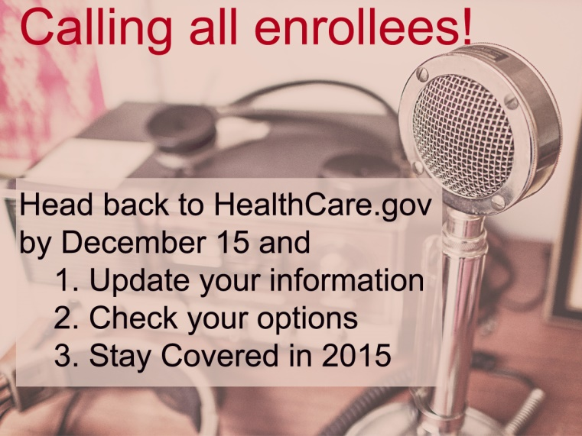 Download here.

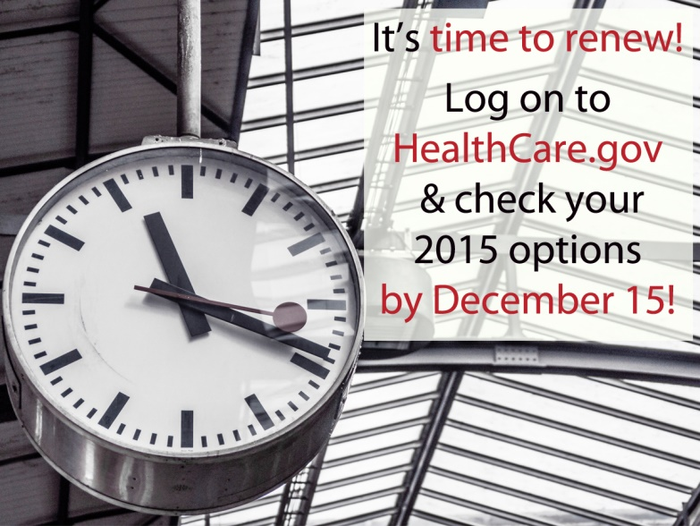 Download here.

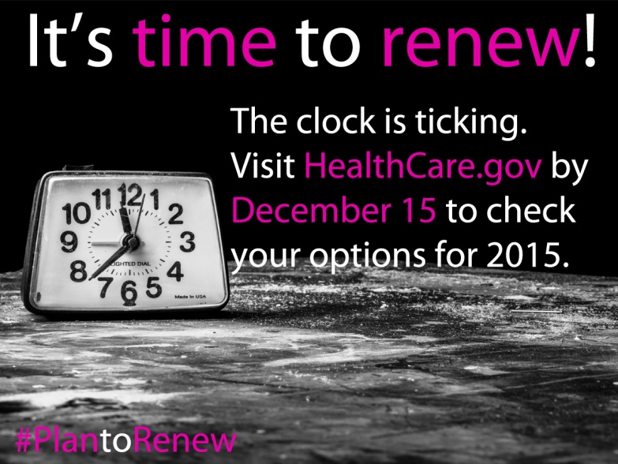 Download here.

